# Executive Summary

This report presents a comprehensive analysis of Jetstar's existing problems, especially frequent flight cancellations and poor customer service, which have contributed to its reputation as Australia's most unreliable airline. To counter these issues, this report proposes some digital innovation strategies: firstly, a Real-time Update System Upgrade to enhance flight status notifications and customer service; secondly, an App Interaction Upgrade for a more user-friendly booking experience; and thirdly, a Flight Plan Forecast Upgrade utilizing weather forecasting and historical data. Our model evaluation suggests that by leveraging existing digital infrastructure, these strategies can minimise travel disruptions and maximise customer satisfaction. Additionally, this report aims to promote social and human wellbeing through the integration of personalized assistance profiles with a real-time chatbot, and advocate for digital economic practices by introducing a transparent carbon emission calculator and a sustainable travel marketplace. These initiatives can provide a more satisfying customer experience, keep the loyalty of current customers, and attract new customers with innovative features.

# A. Business problem identification

Jetstar Airways Pty Limited is an Australian low-fare airline, that faces a substantial operational challenge, specifically about flight punctuality and poor customer experience. Jetstar flies 19 Australian domestic and 13 overseas destinations. The company is currently the 3rd largest airline in Australia and a top 5 international airline by capacity share. (Jetstar n.d.)

For the past decade, Jetstar has enjoyed dominance in its market segment, particularly after the transition of Virgin into a full-service carrier and the cessation of Tigerair in 2020, followed by the emergence of Bonza in 2023. (Australian Competition and Consumer Commission 2022) With a rapidly growing middle class and increased travel demand after the COVID-19 pandemic, the low-cost carrier market is forecasted to grow at 16.3% from 2023 to 2030. (Market Research Future 2022) Jetstar however shows its incapability in catching up the rebound of travel demand. (Appendix Figure 1) According to the Australian Competition and Consumer Commission (ACCC), Jetstar accounts for having a “relatively larger reduction in capacity compared to other airlines” due to the 5% drop in market share despite the market growth. (Appendix Figure 2) (Australian Competition and Consumer Commission 2022)

This could be explained by its reputation of being Australia’s most unreliable airline. (Wootton 2023) Frequent delays and cancellations, coupled with poor customer service contribute to the crisis. According to OAG Aviation, Jetstar’s on-time performance ranked 120th out of 130 airlines in 2022. (OAG Aviation 2022) Jetstar’s flights recorded around 40% late departures and 35% late arrival, compared with 26.1% and 26% respectively for the entire sector. (Wootton 2023) The cancellation rate is recorded to be 11.9% which is 50% higher than the industry rate in the 2020-2021 financial year. (Bureau of Infrastructure and Transport Research Economics 2022) Jetstar is also rated 1.3 out of 5 among 6,317 customers’ reviews, reflecting customers’ dissatisfaction. (ProductReview.com.au. 2023)

The decline in market share indicates the backfire of the business problems. These challenges, if left unaddressed, have the potential to continue diminishing customer satisfaction, and eventually erode Jetstar's market standing. As the aviation landscape evolves, meeting these challenges head-on is crucial for Jetstar's sustained success and competitiveness in the industry. Jetstar can pave the way for operational excellence by leveraging technologies to facilitate flight schedules, and minimize delays, hence enhancing overall efficiency. Coupling with improved customer intimacy, not only resolves immediate problems but also cultivates a better passenger experience.

Low-cost carrier competitors are leveraging digitally native and customer-centric strategies to transform passenger experiences. Delta and Singapore Airlines implemented predictive analytics systems to minimize delays by analysing real-time data, weather forecasts, and historical patterns. (Jiang Y, Tran TH & Williams L 2023) Zappos is known for its customer-centric approach. It streamlines communication and provides timely assistance through implementing chatbots, mobile apps, and AI-powered customer service tools. (Solomon 2017)

Addressing Jetstar's business problem head-on isn't just a strategic move—it's the key to ensuring operational excellence and customer intimacy, stopping the declining trajectory. Fostering long-term success in an industry.

# B. Customer need analysis and value propositions

## B.1 a) Identify the potential targeted customers of the digital solutions

Based on Business problem identification, the target is students who does not have a lot of budgets for flight ticket, parents who often needs customer service for trouble shooting and someone who is going business trip frequently and places premium on punctuality. Based on Section A, the potential targeted customers of the digital solution can be frequent flyers of Jetstar who have experienced delays or cancellation, potential travellers looking for affordable flight options and customers who prioritize punctuality and customer service.

Responses show that based on underlying values such as Importance of time and customer service, easy purchase, value for money, Jetstar has the pain points which are frequent flight delays, cancellations, lack of communication.

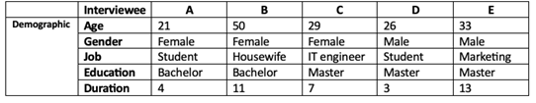

## 

## B.1 b) A summary and insights into the interview results

Across the five interviews, several common themes and insights emerge regarding travellers' experiences and considerations with Jetstar.

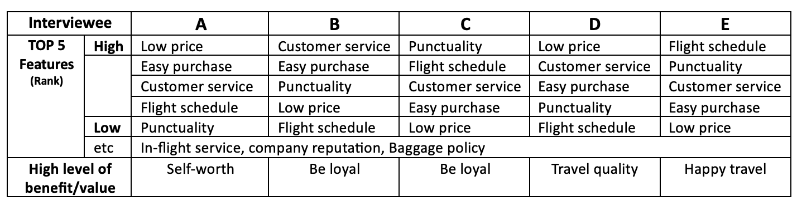

In the first interview, while satisfaction levels varied across different Jetstar services, the airline's website was notably marked low for usability. Besides price, for this traveler, punctuality, customer service, and digital platforms is not just about comfort but essentially about their quality of trip. The second interviewee had a negative experience related to customer service. She has mentioned unexpected flight cancellations and delays without adequate prior notice. This has led to disruptions in travel plans and inconvenience. Also, Issues with the Jetstar website or app causing booking complications, as well as long check-in lines at the airport, have been highlighted. The third respondent who usually do business trips placed significant emphasis on timely arrivals, and the efficiency of the ticket booking system. The fourth interview reemphasized the recurrent themes of price, customer service, and easy access to purchase as primary considerations. A balanced flight experience that is cost-effective and time-efficient was the ideal scenario. However, this respondent also faced technical challenges with Jetstar's app, leading them to use it less frequently. Lastly, for the fifth individual who is a businessman, various options for flight and punctuality took centre stage. The need for an airline to provide real-time notifications, an efficient booking system, prompt service, and especially a quick rescheduling service was of utmost importance. This was accentuated by an experience where a flight cancellation by Jetstar had disrupted their plans.

Customers prioritize price, ease of purchase, good customer service, a variety of flight schedules, punctuality such as flight cancellations, delays, and rescheduling that has a direct impact on users' schedules and plans when selecting flights. Based on the interview, Jetstar can improve its offerings and user experience by focusing on reliability, enhancing digital interfaces, ensuring timely and transparent communication regarding any changes or disruptions to their service. A holistic approach that considers the entire customer journey, from booking to landing, will be essential for positive long-term customer relationships.

## 

## B.2 a) The overall consolidated HVM diagram

The High Value Model developed from interview insights reveals that customers prioritize punctuality, affordability, and efficient customer service.

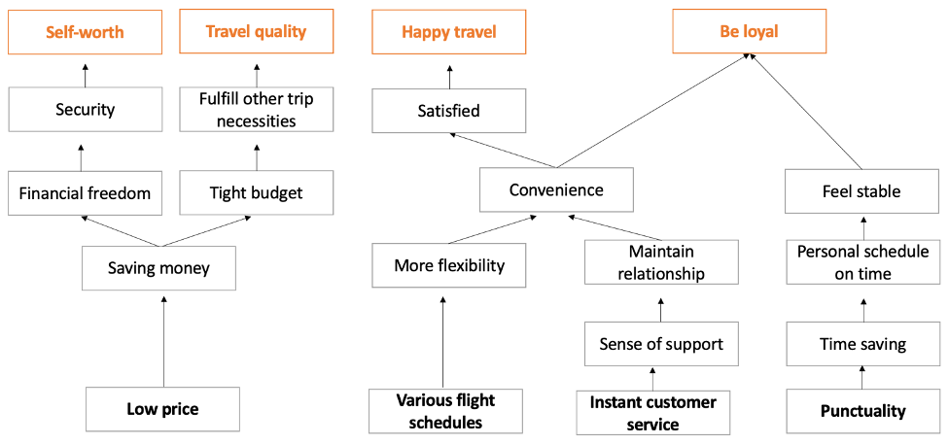

## B.2 b) The value propositions

Jetstar's value proposition centres on delivering convenience, affordability, and reliability to budget-conscious travellers through an enhanced digital experience. The digital solutions aim to simplify the booking process, provide real-time flight updates, and offer responsive customer service, addressing key pain points for students, families, and business travellers (Appendix Figure 4).

Each value proposition directly addresses the operational challenges highlighted in Business problem identification. For example, real-time flight updates and a responsive customer service chatbot tackle the problem of poor customer communication and flight punctuality. And user-friendly booking system addresses the pain points related to digital platform usability. These solutions aim to provide cost-effective travel options, enhance customer satisfaction, and improve Jetstar's operational efficiency, thereby directly targeting the root causes of the decline in market share. For students and budget travellers, Jetstar offers low-cost flights with additional savings through flexible date searches. Especially, business travellers receive services focused on efficiency, such as flexible ticketing.

Jetstar's digital solutions aim to satisfy essential travel needs: affordability, time-saving features, flexibility in booking and managing flights, and dependable customer service. The needs for quick access to affordable flights, streamlined booking alterations, timely notifications about flight changes and effective resolution of service issues are at the forefront of Jetstar's customer-focused approach.

# C. Digital Innovation and implementation

## C.1 Digital Solution

According to previous interviews and studies, customers attach great importance to price and time cost, in addition to a good app experience, which can greatly enhance the user experience when purchasing tickets. Therefore, a series of digital upgrades will be carried out to meet customer needs and experience, to attract more customers to Jetstar.

**Strategy 1: Real-time Update System Upgrade**

A real-time update system is necessary to notify users more efficiently for them to be able to schedule their trips more efficiently. For example, when it comes to flight plan changes and discounted ticketing opportunities. Users receive timely notifications, so they have plenty of preparation time to respond. This enhances the user experience and reduces user complaints. These two drawbacks are the most faced by Jetstar now.

Function 1: Enhanced flight status updates

Jetstar plans to establish a Tripartite Linkage System that will integrate its sales system APIs with live passenger updates, weather forecast inputs, and internal seat availability data. This integrated network will feed into an advanced decision-making system, which will enable the airline to modify flight statuses in real time. The main goal behind this initiative is to provide passengers with early insights into potential travel changes, which will enhance their planning capabilities and overall travel experience while reducing the likelihood of dissatisfaction due to last-minute disruptions.

Function 2: Low price notification

In addition to providing flight status updates, customers can personalize dates and destinations to learn about the latest low-cost offers in real time. In this way, customers are the first to receive discount offers from airlines, which in turn increases their willingness to buy at that time, leading to higher seat occupancy rates and sales. At the same time, it also improves the stability of the aircraft schedule, which will not be easily cancelled or delayed.

Function 3: Real-time proactive multi-channel customer service

During the research, it is shown that passengers rarely received notifications from Jetstar. The real-time information mentioned above requires attention to its notification channels. A multi-channel approach, including app alert notifications, email, and SMS, is more effective in ensuring that customers receive timely and relevant information.

**Strategy 2: App Interaction Upgrade**

The use of the APP has also been complained about by many users, and it is necessary to upgrade it as one of the most important ticketing channels nowadays, mainly from the internal operation of the APP and AI customer service.

Function 4: Convenient app operation instead of web hopping

Today's Jetstar app provides a poor user experience due to its frequent need to redirect to web pages for various operations. This is a great inconvenience and results in a waste of the app's advantages. Developing a complete set of in-app functions would significantly enhance the user experience.

Function 5: Chatbot upgrades to provide direct solutions to problems.

Although Jetstar has launched an AI customer service feature, it is clearly not as effective or even helpful to customers and needs a series of upgrades and optimizations. For example, it provides direct solutions and guidance to customers on how to refund their tickets or change their itinerary instead of double-checking the status of the airplane.

**Strategy 3: Flight plan forecast upgrade**

In addition to real-time updates of information, Jetstar should proactively use the data to make targeted predictions about the future to avoid unnecessary delays and cancellations which is a big turn-off for users. Weather forecasting and historical data analysis can further enhance the stability of flight plans.

Function 6: Weather forecasting.

The weather factor is one of the important reasons for Jetstar to cancel or delay flights, this problem can be cited in the scope of operation of similar Qantas, Singapore Airlines uses a weather forecasting system for the landing and takeoff airport future weather conditions can be analyzed. According to Jetstar's internal landing and takeoff weather requirements combined with the real-time data update system mentioned above, earlier notification or response to maintain a good brand reputation and image.

Function 7: Historical data analysis.

Jetstar can develop a data collection and storage system to analyze its operations and use the insights gained for future forecasting. By leveraging machine learning and AI, Jetstar can analyze customer demand on different routes in each period and make informed decisions like cancelling flights early and discouraging customers from buying if attendance is projected to be too low. This helps avoid the hassle of subsequent refunds. Additionally, the data can be used to improve aircraft maintenance and overhaul programs, reducing delays and cancellations caused by technical issues.

## C.2 Potential Challenges and Risks

To successfully implement the innovative solutions proposed for Jetstar, it is essential to have a comprehensive rollout plan that addresses potential challenges and risks. Firstly, handling increased amounts of customer data for real-time updates and personalised notifications raises concerns about data privacy and security. To solve this problem, Jetstar should work with cybersecurity experts to ensure all data handling complies with relevant data protection regulations.

Secondly, the App Interaction Upgrade may face user resistance to change. To overcome this, Jetstar should ensure feature parity between its website and application, as well as consistency in user experience. Jetstar needs to conduct user experience research, carry out surveys, and focus on understanding user needs and preferences. Based on this, the development of app functions should proceed in stages, prioritizing those that users most frequently access through the website. Furthermore, before releasing the new app, Jetstar should select a user group to test it, ensuring that every function is user-friendly. Additionally, in-app support will be crucial to assist users in adapting to the new app functionalities.

Thirdly, the risk associated with the Flight Plan Forecast Upgrade is the reliance on external data sources for the accuracy of weather forecasts and historical data analysis. It is critical to ensure the reliability and accuracy of real-time updates, weather forecasts, and historical data analyses. Customers will be dissatisfied if flights are cancelled due to incorrect predictive models. Jetstar should collect extensive historical data to train the predictive models, and then integrate them with the flight planning decision systems. Moreover, after the full implementation of this strategy, manual oversight is necessary to confirm the accuracy of the predictive decisions.

## C.3 Promote the Innovation Solutions

The target customer segment for Jetstar is the travellers who value efficiency, travel quality and personalised experiences. Promoting these innovative solutions requires some strategies that resonate with these travellers:

1. Through digital media such as Instagram and Twitter, we can accurately push advertisements to customers who travel frequently. Advertisements can be designed as interactive demonstration videos to show users the usefulness of the new system and attract users to try and download the new system.
2. Send personalized emails to exist customers, highlighting the new features with a call-to-action to download or update the app.
3. Offer bonus points or discounts for users who engage with the new system features to encourage user interaction.

By focusing on cybersecurity for data protection, upgrading the app based on user feedback, and ensuring the reliability of predictive models, Jetstar can effectively manage potential challenges. These steps will not only increase Jetstar's competitive edge in the travel industry but also prove its commitment to innovation and customer satisfaction.

# D. Evaluation of the digital platform model

Our proposed digital solution for the company can adopt a digital platform model. Conceptually, a digital platform serves as an interface that enhances service quality by connecting customers with platform providers. In the solution, Jetstar's customers represent one side of the consumer spectrum, while Jetstar itself provides value on the other. Our innovative proposal acts as a new, vital link establishing closer connections between these two parties. In other words, the innovations in Part C are grounded in the digital platform model.

The key value proposition in this innovation is to enhance user information awareness, thereby improving service quality and reducing the likelihood of flight cancellations. These initiatives are crucial for enhancing user perception of Jetstar. As mentioned in Part A and Part B, the quality of Jetstar's service and its high cancellation rates have become key factors limiting its further development. The solution focuses on improving service quality and reducing cancellation rates, precisely addressing pain points in the user consumption process, enhancing customer loyalty, and attracting new users to enjoy the conveniences brought by this digital platform. Considering the network effects and success factors of digital platforms, our solution mainly improves Jetstar's current situation in the following aspects:

Firstly, by upgrading the existing systems, we can better utilize existing resources, save on development costs, and help retain the current user base. With Jetstar's large existing customer base, the comprehensive rollout plan mentioned earlier can quickly initiate the digital platform, thereby establishing the network effects in the digital platform model. This established network effect belongs to the Same Side Network Effect, reducing the likelihood of flight cancellations due to high vacancy rates, as mentioned earlier, thus enhancing the user experience.

Additionally, the design also leverages the openness of the digital platform model. For instance, by integrating open weather prediction API interfaces, we can better perceive real-time changes in weather conditions. Using this weather information, the system, under corporate governance, can automatically couple flight conditions with preset parameters. This allows for faster and more accurate judgments of the impact of weather conditions on flight status. Utilizing the advantages of the digital platform, this information can be rapidly disseminated to flight users. Compared to traditional manual calculations, this method speeds up the aggregation and processing of information, thereby enhancing the user experience.

Finally, the design also focuses on improving the "interaction" experience within the digital platform model. By increasing channels and introducing artificial intelligence chatbots, the interaction experience can be significantly enhanced. Take the chatbot as an example: previously, customer inquiries required sequential manual responses. Due to the limited number of customer service representatives, responses were often delayed, leading to a decline in user experience. AI customer service can respond in real-time and resolve most customer queries. This significantly reduces user waiting time, allowing the company to focus on issues that genuinely require human intervention. Both aspects of the interaction experience are improved within this model. (Alstyne 2016)

# E. Potential approaches for being a responsible business

When developing responsible business, a critical lens on responsible information systems is essential. Social Corporate Digital Responsibility and Economic Corporate Digital Responsibility aspects from the ‘Four Categories of Digital Responsibility’ framework will be further investigated. By integrating advanced technologies, Jetstar could position itself as a responsible player in the airline industry.

*Social CDR - Promoting Social and Human Wellbeing:*

In alignment with Social Corporate Digital Responsibility, upgrading the Chatbot (Function 5) could enhance passenger experiences through personalized solutions.

To elevate the customer experience, Jetstar could introduce the innovative features - Personalized Assistance Profiles and Real-time Assistance Chatbot. The personalized profile empowers passengers to create and manage profiles within the app, detailing their unique requirements like dietary restrictions, mobility needs and communication preferences. The chatbot harnesses AI to provide instant and tailored support for passengers. For example, encompassing guidance through the airport, addressing in-flight needs, and offering personalized assistance. The feature does not only streamline customer interactions but also creates a more inclusive travel experience, fulfilling Social Corporate Digital Responsibility.

*Economic CDR - Advocating for Digital Economic Practices:*

Aligned with Economic Corporate Digital Responsibility, the Flight plan forecast upgrade (Strategy 3) could integrate the Transparent Carbon Emission Calculator and the Sustainable Travel Marketplace. This approach does not only foster sustainability and supports local economies.

Jetstar could integrate a Transparent Carbon Emission Calculator within the Convenient app operation. This innovative feature calculates and presents the carbon footprint of each flight to passengers at the booking stage. Jetstar thus encourages customers to make eco-conscious travel decisions, fostering a culture of sustainability in the industry. The Flight plan forecast upgrade (Strategy 3) could also include a Sustainable Travel Marketplace. This integrated feature goes beyond weather and flight forecast, showcasing local businesses at airports and forming partnerships with enterprises. Passengers gain access to exclusive deals and promotions through the app, fostering conscious consumerism and supporting local economies. This strategy promotes responsible economic practices, providing passengers not only with budget-friendly options, creating a more holistic travel experience.

These features not only align with the responsible information systems framework but also add valuable dimensions to Jetstar's digital solution, enhancing both the customer experience and the airline's commitment to social and economic responsibility.

# Appendix

|  |  |
| --- | --- |
| Figure 1 Australian domestic market: capacity (seats), 2019-2022   | Figure 2 Australian domestic airlines by market share, Jan-2019 to Apr-2022   |

The interview analysis of this step (i.e., diagrams of ladders and independent HVMs) should be provided in the Appendix and referred to in the main writing of this report. (Figure 3)

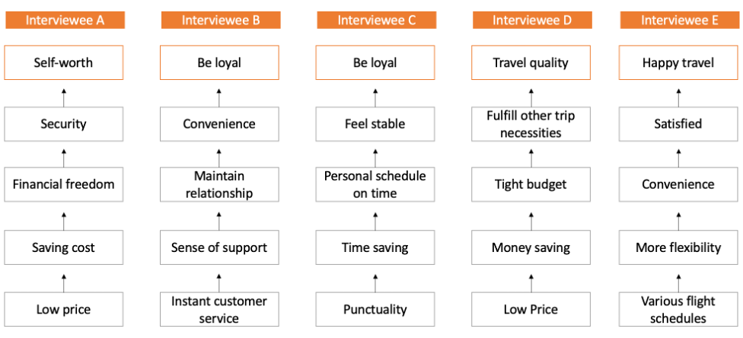

Value Proposition (Figure 4)

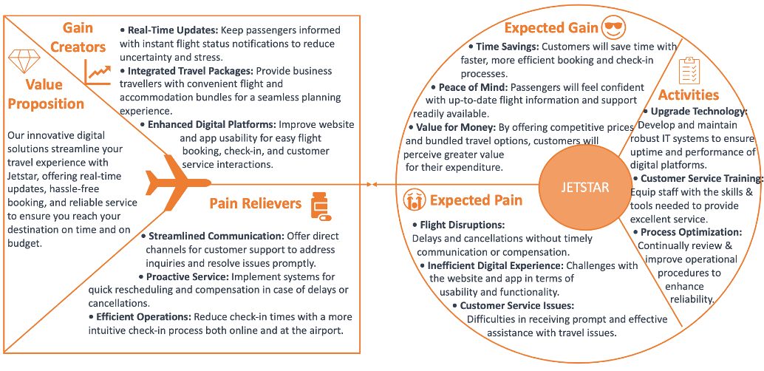

# References

[1] Australian Competition and Consumer Commission 2022, Airline Competition in Australia, https://www.accc.gov.au/system/files/Airline%20competition%20in%20Australia%20-%20March%202022%20report.pdf.

[2] Bureau of Infrastructure and Transport Research Economics 2022, Airline on time performance, 2021-22 Financial Year Report, https://www.bitre.gov.au/statistics/aviation/otp_annual.

[3] Market Research Future 2022, Low cost carrier (LCC) market trends, growth, forecast 2030, https://www.marketresearchfuture.com/press-release/low-cost-carrier-market#:~:text=Oct%202022%2C%20MRFR%20Press%20Release,Cost%20Carrier%20(LCC)%20Market.&text=The%20global%20Low%20Cost%20Carrier%20(LCC)%20market%20is%20projected%20to,forecast%20period%2C%202023%E2%80%932030.

[4] Jiang, Y, Tran, TH & Williams, L 2023, 'Machine learning and mixed reality for smart aviation: Applications and challenges', Journal of Air Transport Management, vol. 111, no. 102437, https://doi.org/10.1016/j.jairtraman.2023.102437.

[5] OAG Aviation 2022, On-time Performance Airlines - July 2022, https://www.oag.com/en/on-time-performance-airlines-july-2022.

[6] Wootton, H 2023, 'Jetstar cancels the most flights, runs the latest of any airline', Australian Financial Review, https://www.afr.com/life-and-luxury/travel/jetstar-cancels-the-most-flights-runs-the-latest-of-any-airline-20230622-p5dinb.

[7] Jetstar Airways n.d., Jetstar, https://www.jetstar.com/au/en/about-us/jetstar-group/jetstar-airways.

[8] ProductReview.com.au 2023, Jetstar reviews, https://www.productreview.com.au/listings/jetstar.

[9] Solomon, M 2017, 'If chatbots win, customers lose, says Zappos customer service expert', Forbes.

[10] Van Alstyne, MW, Parker, GG & Choudary, SP 2016, 'Pipelines, platforms, and the new rules of strategy', Harvard Business Review, vol. 94, no. 4, pp. 54-62.